CO3-AT2
CASE STUDY BASED

NAME : S.PON SURYA
REG NO : 192411145

SOURCE CODE
Q26) def merge_sort(bookings):

# Base case
if len(bookings) <= 1:
return bookings

# Divide
mid = len(bookings) // 2

left = merge_sort(bookings[:mid])
right = merge_sort(bookings[mid:])

# Merge
return merge(left, right)

def merge(left, right):

result = []
i = 0
j = 0

while i < len(left) and j < len(right):

# Sort by departure time first,
# then by priority.
if (left[i]["departure"], -left[i]["priority"]) <= \
(right[j]["departure"], -right[j]["priority"]):

result.append(left[i])
i += 1

else:
result.append(right[j])
j += 1

# Add remaining elements
result.extend(left[i:])
result.extend(right[j:])

return result

# Airline reservation data
bookings = [
{"id": "B101", "departure": "10:30", "priority": 2},
{"id": "B102", "departure": "08:15", "priority": 1},
{"id": "B103", "departure": "10:30", "priority": 1},
{"id": "B104", "departure": "07:45", "priority": 3},
{"id": "B105", "departure": "09:20", "priority": 2},
{"id": "B106", "departure": "08:15", "priority": 3}
]

print("==============================================")
print("AIRLINE RESERVATION SORTING SYSTEM")
print("==============================================")

print("\nBefore Sorting:")
for booking in bookings:
print(booking)

sorted_bookings = merge_sort(bookings)

print("\nAfter Sorting:")
for booking in sorted_bookings:
print(booking)

print("\nTime Complexity: O(n log n)")
print("Space Complexity: O(n)")

REPORT
Title
Airline Reservation Sorting System Using Merge Sort
Aim
To analyze and apply Merge Sort for sorting airline bookings based on departure time and priority using the divide-and-conquer technique, and evaluate its efficiency for large volumes of reservation data.
Problem Statement
An airline reservation system handles a large number of flight bookings that need to be sorted according to departure time and booking priority. The system must provide stable and efficient sorting while handling large datasets and frequent booking updates.
Merge Sort is applied because it divides the data into smaller parts, sorts them, and merges them efficiently.
Output
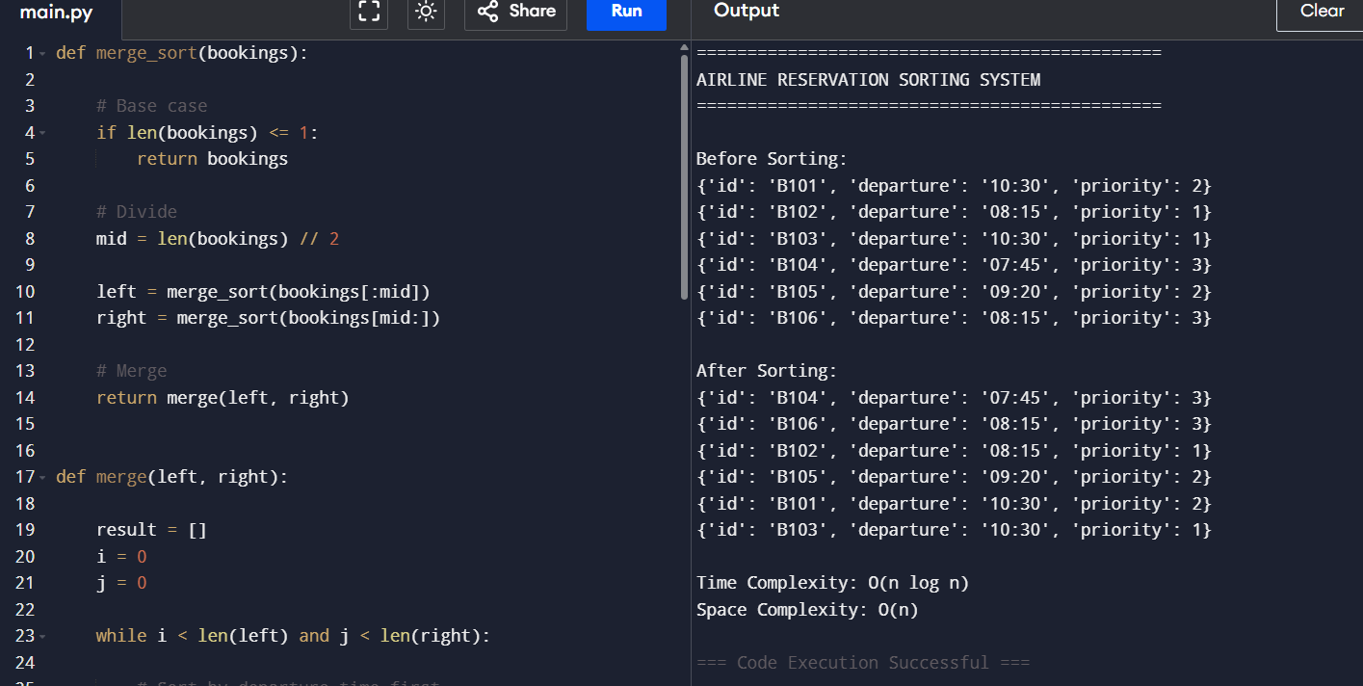
Output Analysis
The program successfully sorts the airline bookings according to:
- Departure time – earlier flights are placed first.
- Priority – for bookings with the same departure time, higher-priority bookings are placed first.
Example output:
Before Sorting:
B101 - 10:30 - Priority 2
B102 - 08:15 - Priority 1
B103 - 10:30 - Priority 1
B104 - 07:45 - Priority 3
B105 - 09:20 - Priority 2
B106 - 08:15 - Priority 3

After Sorting:
B104 - 07:45 - Priority 3
B106 - 08:15 - Priority 3
B102 - 08:15 - Priority 1
B105 - 09:20 - Priority 2
B101 - 10:30 - Priority 2
B103 - 10:30 - Priority 1
The output confirms that the bookings are correctly arranged using the required sorting criteria.
Time Complexity
Merge Sort follows the recurrence:
Therefore:
Case | Time Complexity
Best Case | O(n log n)
Average Case | O(n log n)
Worst Case | O(n log n)
This predictable complexity makes Merge Sort suitable for large booking datasets.
Space Complexity
Merge Sort requires additional temporary storage during the merging process.
Therefore:
- Time:
- Space:
Conclusion
Merge Sort provides an efficient and stable solution for sorting airline reservations. Its time complexity makes it suitable for large volumes of booking data, while its space complexity is the main memory requirement.
For continuously changing reservations, Merge Sort can be combined with a priority queue or indexed data structure to handle real-time updates efficiently.

